- Title： Parsing IP packets
No. 3

Name: Khan Md Shahedul Islam
Stu No.: 2018380130
Class No.: 10101801
Time: 2020/11/13

School of computer science and Engineering, NWPU

Content

1 Purpose of the experiment 1
2 Steps for the experiment 1
3 Problems happened to the experiment 1
4 Results and analysis 3

Purpose:
By analyzing IP packets we can understand the working principle of IP,ARP,TCP,HTTP and DNS protocols

Experimental Steps and Results:
- File run according to cmd lines: DOS>ParsePacket log file
- Output: IP packet field values: version, header length, service type, total length, identification, segmentation flag, segmentation offset, survival time, upper protocol type, header checksum, source IP address, purpose IP address.

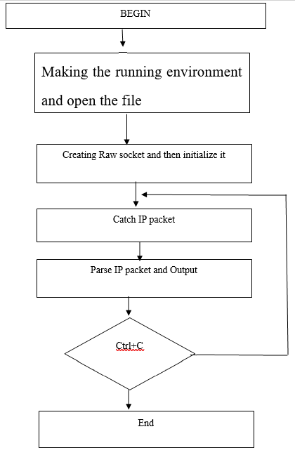

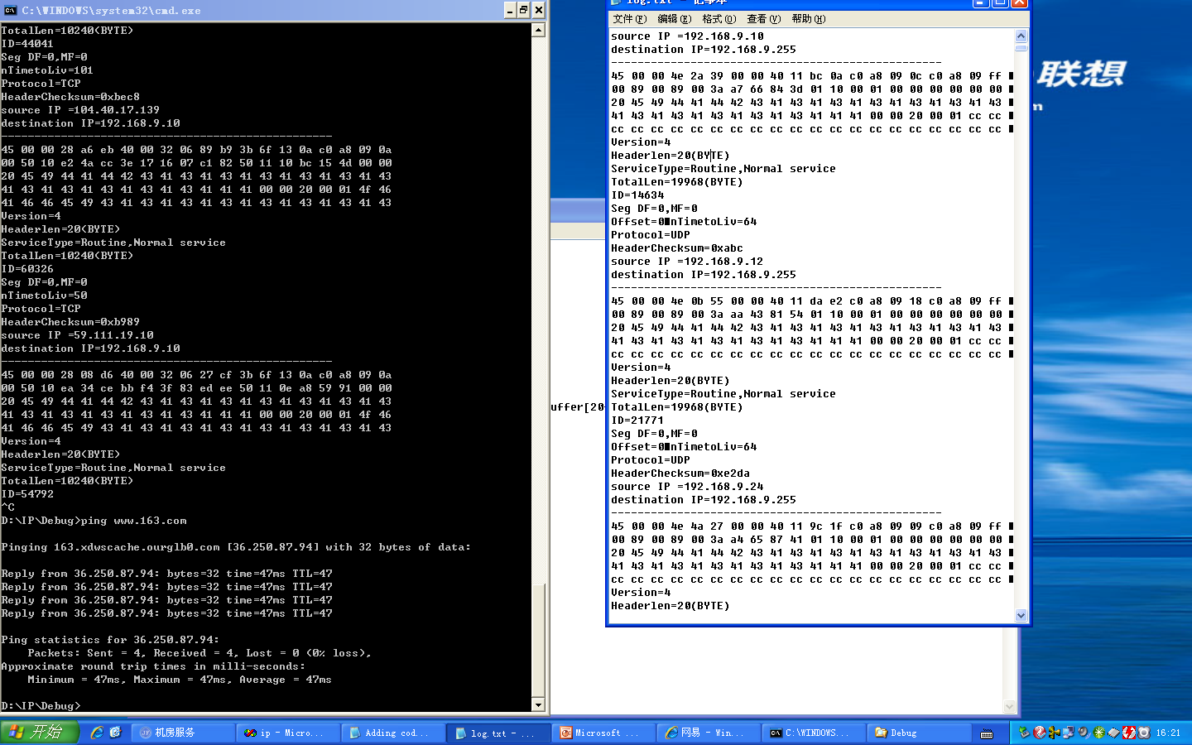

Sample from our code output (Both execution and log file we saved to):
For example:
01 bb 10 fc 30 e4 a8 34 f2 ea 4d 76 50 11 0b 68 60 12 00 00
31 94 6c ac 37 ab fe dd e5 8d 22 c3 be 8e 96 58 8b c2 5a e6
b8 0c 0a e9 4f 89 7f da 4f 0b 21 41 35 e6 63 20 23 93 0f 88
0a 5f 56 c8 43 cb 85 c6 03 94 c4 31 c0 e2 7c 9e b0 5a 79 99
Version=4
Headerlen=20(BYTE)
ServiceType=Routine, Normal service
TotalLen=10240(BYTE)
ID=34160
Seg DF=0, MF=0
Offset=64
nTimetoLiv=50
Protocol=TCP
HeaderChecksum=0x22c0
source IP =59.111.19.7
destination IP=192.168.9.10
When parsing the following captured ip packet:
IP Version: 4
Internet Header Length (32-bit words): 5
Total Length (header + data) bytes: 40
Time To Live: 50
Protocol: 6
Source IP: 59.111.19.7
Destination IP: 192.168.9.10
Data offsets are all 0-indexed
Data starts at bit off-set: 160
Data starts at byte off-set: 20
Data starts at 32-bit word off-set: 5
Protocol type is TCP
Source Port: 443
Destination Port: 4348
Flags:
Binary: 10001
Integer: 17
Hex: 11
Unparsed Hex: 011
Symbols:
Reserved 96+4: NOT SET
Reserved 96+5: NOT SET
Reserved 96+6: NOT SET
NS 96+7: NOT SET
CWR 96+8: NOT SET
ECE 96+9: NOT SET
URG 96+10: NOT SET
ACK 96+11: SET
PSH 96+12: NOT SET
RST 96+13: NOT SET
SYN 96+14: NOT SET
FIN 96+15: SET
Three way handshakes

he so-called three-way handshake (Three-Way Handshake) means establishing a TCP connection, which means that when a TCP connection is established, the client and the server need to send a total of three packets to confirm the establishment of the connection. In socket programming, this process is triggered by the client executing connect, the whole process is as shown below:
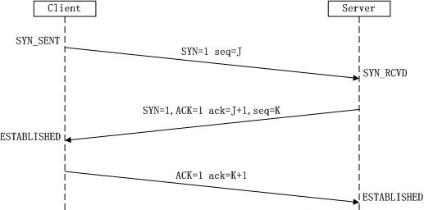
(1) First handshake: Client sets the flag SYN to 1, randomly generates a value seq=J, and sends the packet to the server. The client enters the SYN_SENT state and waits for the server to confirm.
(2) The second handshake: After the server receives the data packet, it is known by the flag bit SYN=1 that the client requests to establish a connection. The server sets the flag bits SYN and ACK to 1, ack=J+1, and randomly generates a value seq= K, and the datagram is sent to the Client to confirm the connection request, and the Server enters the SYN_RCVD state.
(3) The third handshake: After the client receives the acknowledgment, it checks whether ack is J+1, whether the ACK is 1, and if it is correct, sets the flag ACK to 1, ack=K+1, and sends the packet. Server, Server checks whether ack is K+1, ACK is 1. If it is correct, the connection is successful, Client and Server enter ESTABLISHED state, complete three-way handshake, and then the client and server can start to transfer data.
Four way Wave release
The so-called Four-Way Wavehand terminates the TCP connection, which means that when disconnecting a TCP connection, the client and the server need to send a total of 4 packets to confirm the disconnection of the connection. In socket programming, this process is triggered by either the client or the server executing close, as shown in the following figure:
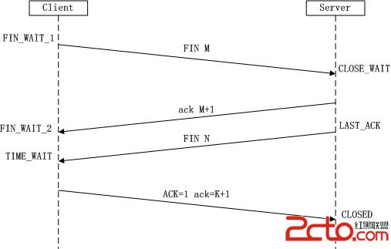
Since the TCP connection is full-duplex, each direction must be closed separately. The principle is that when one party completes the data transmission task, it sends a FIN in the Champions League to terminate the connection in this direction, and receives a FIN. This means that no data flows in this direction, ie no more data is received, but the data can still be sent on this TCP connection, knowing that FIN is also sent in this direction. The party that first shuts down will perform an active shutdown while the other party performs a passive shutdown, as described in the figure above.
(1) The first wave: The client sends a FIN to close the data transfer from the client to the server, and the client enters the FIN_WAIT_1 state.
(2) The second wave: After the server receives the FIN, it sends an ACK to the client, confirming that the serial number is the received sequence number +1 (same as SYN, one FIN occupies a sequence number), and the server enters the CLOSE_WAIT state.
(3) The third wave: The server sends a FIN to close the data transfer from the server to the client, and the server enters the LAST_ACK state.
(4) The fourth wave: After the client receives the FIN, the client enters the TIME_WAIT state, and then sends an ACK to the server, confirming that the serial number is the received sequence number +1, the server enters the CLOSED state, and completes the wave wave four times.
If one of the above parties is actively shut down and the other party is passively shut down, the actual situation of simultaneous active shutdown will occur. The specific process is as follows:
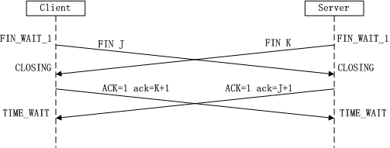

Problems Encountered:
Understanding the way wireshark works
Internet connection problem(several times computer got disconnected from the network)
understand the complex mechanisms used to send and receive data over a network

Analysis:
I have successfully used wireshark to catch packet of the ip address, been able to explain the details of each packets from the TCP header as well as the UDP header. I have also analyzed IP packets and understood the working principle of IP protocol.

